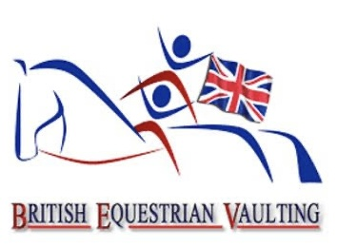
WELCOME TO THE
VAULTING COMMUNITY
A starter guide for new British Equestrian Vaulting clubs
START SMALL
You don't need everything on day one. Start with the right people, a suitable horse, a safe environment and a willingness to learn.

For any help you may need on your journey.
Regional Representatives
Scotland- Kirsty Campbell -Info@ridersofthestorm.co.uk
England- Suzi Cusick -sd_shortland@hotmail.com
Wales- Chris Rogers - talygarnvaulters11@gmail.com

Start small • Ask questions • Get help • Build from there

Welcome to British Equestrian Vaulting
Your first steps into the vaulting community
Dear New Vaulting Club,
A very warm welcome to British Equestrian Vaulting! We are delighted that you are interested in starting a vaulting club and joining our growing community.
Vaulting combines gymnastics, teamwork, movement and horsemanship. Best described as “gymnastics on a moving horse”, with the horse working on a 15-metre circle under the control of a lunger.
A NEW CLUB DOES NOT HAVE TO BE PERFECT
If you have an idea, a suitable horse, a group of enthusiastic people or simply a desire to give vaulting a try, get in touch. Develop safely and progressively.

So, you want to start a vaulting club?
Think about four foundations
01 PEOPLE  Coach • lunger • helpers • vaulters • safeguarding • first aid • administration | 02 HORSE  A suitable, calm, well-prepared horse whose welfare comes first
03 VENUE  Safe arena/space • footing • mounting area • warm-up/gymnastics space | 04 EQUIPMENT  Start with essentials and build your kit as the club develops

Your people
Build the right team around the horse and vaulters
A new club should have access to appropriately qualified or experienced vaulting coaching. Vaulting has specialist skills beyond general equestrian coaching.
- Vaulting coach / technical lead
- Competent lunger
- Helpers and volunteers
- Vaulters and group organisation
- Safeguarding arrangements
- First-aid provision
- Club administration
NO VAULTING COACH YET?
BEV offers an accessible route for members to become involved in all aspects of coaching. A Full Level 2 coach (Vaulting and Lunging) is required by BEV to be present and be the coach in charge at all vaulting sessions where a horse is present. A Level 2 Vaulting Coach may join with a Level 2 Lunger to operate a session.
QUALIFICATION REQUIREMENTS OUTLINE
VAULTING LEVEL 2 (To be assessed by a Level 3 Coach)
1. Age 18+
2. Full BEV member
3. Full Disclosure/PVG check
4. Valid safeguarding course (within last 3 years)
5. Valid First Aid certificate (within last 3 years)
6. Have attained Level 1 or have relevant experience/qualifications
7. Complete a Risk Assessment
8. Complete a session plan
9. Attend a BEV or FEI organised CPD event within the last year
10. 20 hours in logbook
OUTLINE OF THE LEVEL 2 VAULTING COACH QUALIFICATION
• May run a Club and sessions in partnership with a Level 2 Lunger
• Coach BEV and 1* compulsories
• Coach Individual and Pas de Deux in canter
• Have a working knowledge of all levels of compulsories including 2* and 3*
• Have a basic knowledge of judging and score sheets.
• Be aware of safe practice around horses
• Have read the BEV Rules
• Prove knowledge of FEI Rules, Guidelines and Code of Practice
• Competition etiquette

QUALIFICATION REQUIREMENTS OUTLINE
LUNGING LEVEL 2 (To be assessed by a Level 3 Coach)
1. Age 18+yrs
2. Full BEV member or BHS Gold membership (provide liability insurance for roles with horses)
3. Full Disclosure/PVG check
4. Safeguarding course (advised but not required)
5. Valid First Aid certificate (within last 3 years)
6. Completed Risk Assessment
7. Proof of having lunged canter classes at two National competitions (required to attain+C)
Required (by BEV) if lunging at a CVI, World or European Championships
OUTLINE OF THE LEVEL 2 LUNGING QUALIFICATION
• May run a club or sessions in partnership with a level 2 Vaulting
• Competent to lunge for a club without supervision
• Must be able to train a horse for vaulting
• Knowledge of travelling horses
• Able to lunge Individuals and Pas de Deux in canter at all levels
• Safe practice when lunging in the company of other horses
• Competent in Horse welfare and care
• Capable of lunging all classes at National Competitions
• Competition etiquette
Please contact your regional rep to find a Level 3 coach who would be able to access you.

Finding your vaulting horse
The horse is at the heart of the sport

Not every horse is suitable for vaulting. A potential horse should be assessed carefully, ideally with an experienced vaulting coach.
- Calm, patient and predictable temperament is the most important
- Comfortable with groups and movement around its body
- Riding club and RDA horses are a great fit to get a club started
- Rhythmic, consistent and appropriate canter for development vaulting but a great walk horse is best to get you started.
- Well, healthy and fit to take on a new job
- They don’t need to be massive 17hh plus horses either, good sturdy cobs are great for getting started

TOP TIP
Before buying a horse specifically for vaulting, ask an experienced BEV coach to assess it with you. From time to time there are horses available to loan from other clubs.

Equipment starter guide
Buy the essentials first — then build

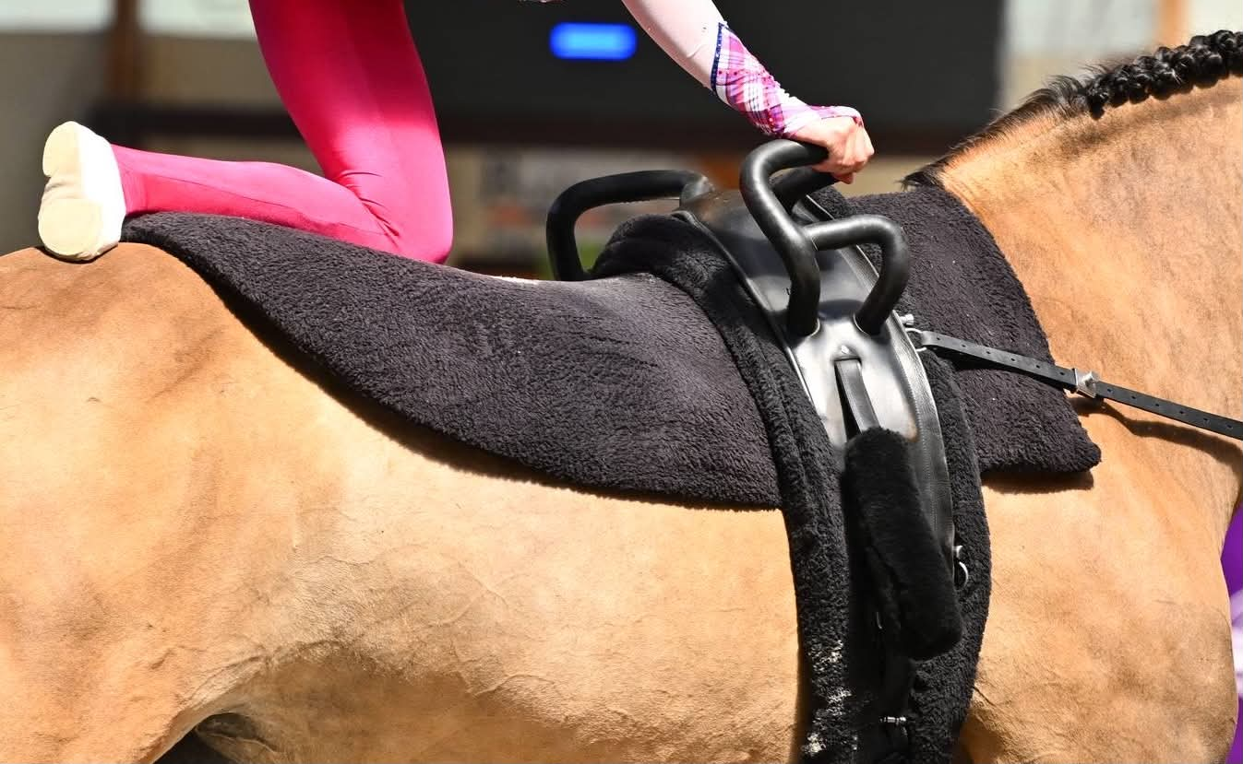
Horse equipment: vaulting surcingle/roller, suitable pad, girth, bridle or lunge cavesson, lunge line, whip and appropriate reins.
Vaulter equipment: vaulting shoes, comfortable close-fitting clothing, securely tied hair and appropriate safety equipment.
Ground equipment: vaulting barrel, mats, gymnastics mats, mounting block, cones, poles, warm-up equipment and first-aid kit.
CHECK FIRST
The current 2026 BEV and FEI rules should be checked before buying equipment intended for competition use.
www.britishvaulting.org/rules/
https://inside.fei.org/fei/disc/vaulting/rules

LIST OF VAULTING KIT SUPPLIERS
www.sattlerei-meinecke.de
https://kristensenvaultingsupply.com/
https://www.kramer.co.uk/Themes/Vaulting
www.esvario.com
The vaulting barrel
Your club's practice horse
A barrel can be one of the best investments for a new club. It lets vaulters learn and practise movements away from the horse.
- Mounts and dismounts
- Basic positions and balance
- Compulsory movements
- Freestyle preparation
- Strength and flexibility
- Team exercises and choreography
IMPORTANT
A training barrel and a competition-suitable barrel are not necessarily the same. Contact BEV for a construction guide or a list of suppliers.

Safety, safeguarding & horse welfare
Build safety into the club from day one
A new club should complete appropriate risk assessments and establish clear procedures before regular sessions begin.
- Safeguarding arrangements
- First-aid provision
- Emergency contacts
- Risk assessments
- Clear roles and supervision
- Safe mounting/dismounting
- Horse welfare plan
- Progressive training
- Appropriate workload
- Suitable tack and equipment
- Regular welfare review
REMEMBER
The horse is a teammate, not a piece of equipment. If something isn't right, stop, assess and seek advice.
Joining BEV
Membership, insurance and registration
ALL VAULTERS, HORSES, COACHES AND GROUPS must be members to be covered by its insurance.
Current categories include
Adult £50,
Youth £40,
Group/Club £40 new / £60 existing,
Horse £40,
Associate £30
Temporary membership free for one trial session.
These are yearly memberships

☐ Contact BEV and introduce your new club
☐ Choose the appropriate membership route
☐ Register members / horse as required
☐ Check insurance arrangements
☐ Read the current BEV rules
CURRENT RULES
The current 2026 BEV and FEI rules links
www.britishvaulting.org/rules/
https://inside.fei.org/fei/disc/vaulting/rules

Your first 90 days
MONTH 1 • EXPLORE
Contact BEV • Find an experienced coach/mentor • Identify a venue • Identify a potential horse • Talk to an established club • Watch or attend a vaulting session

MONTH 2 • PREPARE
Horse assessment • Risk assessments • Safeguarding • First aid • Insurance and membership • Basic equipment • Barrel • Coach/lunger training

MONTH 3 • START
Introductory session • Barrel/gymnastics work • Progressive horse work • Review sessions • Review horse welfare • Build membership • Start CPD • Connect with other BEV clubs
How BEV can support your new club
HORSE ADVICE
Potential horse assessment • Horse suitability • Horse welfare • Training advice

COACHING
Experienced coach connections • Coach development • Vaulting-specific training • Lunger training • Training days

COMMUNITY
Connect with established clubs • Find local opportunities • Work towards BEV competitions • Progress through the sport

Don't worry!
You don't need everything on day one.
YOU DON'T NEED
☐ A squad of 20 vaulters
☐ Your own horse
☐ Every piece of equipment
☐ A competition-ready programme
☐ A fully equipped gym
☐ An experienced vaulting team
YOU DO NEED
☐ Enthusiasm
☐ A commitment to horse welfare and participant safety
☐ Appropriate coaching
☐ A suitable training environment
☐ A willingness to learn
☐ A connection with the BEV community
THE BIG IDEA
Start small. Ask questions. Get help. Build from there.
Useful BEV links
BEV Home https://www.britishvaulting.org/
What is Vaulting https://www.britishvaulting.org/about-vaulting/
Find a Club https://www.britishvaulting.org/clubs/
Join as a Vaulter https://www.britishvaulting.org/join-vaulter/
Register a Horse https://www.britishvaulting.org/join-horse/
BEV Rules https://www.britishvaulting.org/rules/
Contact BEV https://www.britishvaulting.org/contact/

New Club Checklist
A one-page action list
☐ Contact BEV
☐ Identify an experienced coach / mentor and competent lunger
☐ Identify a suitable venue
☐ Identify and assess a potential horse
☐ Create club membership forms and create a club bank account
☐ Complete risk assessments
☐ Put safeguarding and first aid arrangements in place
☐ Check insurance and BEV membership
☐ Read the current BEV rules
☐ Arrange basic equipment
☐ Obtain or borrow a practice barrel
☐ Plan an introductory session
☐ Introduce horse work progressively
☐ Review horse welfare regularly
☐ Start a CPD record
☐ Connect with established BEV clubs

WELCOME TO THE COMMUNITY
You don't have to have everything worked out before you contact BEV.

BRITISH EQUESTRIAN VAULTING
enquiries@britishvaulting.org • www.britishvaulting.org

